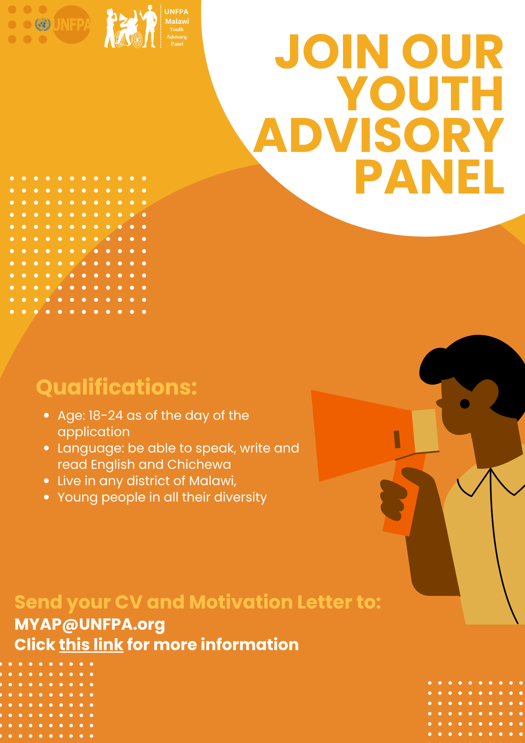

Call for Applications: The UNFPA Malawi Youth Advisory Panel (M-YAP)
Are you a young Malawian citizen aged between 18 and 24 years, passionate about Sexual Reproductive Health and Rights (SRHR), and eager to make a positive impact on the health and well-being of adolescents and youth in Malawi?

The United Nations Population Fund (UNFPA) Malawi Country Office is excited to invite dynamic and dedicated young volunteers to join its Youth Advisory Panel (YAP).

About UNFPA Malawi:
UNFPA is the leading United Nations agency committed to ensuring that the potential of every young person is realized. In pursuit of this mission, UNFPA is aiming to collaborate with a group of motivated young individuals through the Youth Advisory Panel (YAP). This platform will ensure that our programs are attuned to the unique needs of young people, while also offering youth the opportunity to learn, engage in policy development, and contribute to initiatives that impact their lives.

In a country where nearly 80% of the population is below 35 years of age, our programming and development work necessitate placing young people at the forefront of our efforts.

The Role of the UNFPA Youth Advisory Panel:
The UNFPA Youth Advisory Panel serves as a vehicle for young people to exercise their rights, utilizing their age and lived experiences to advance outcomes in alignment with the Sustainable Development Goals. It exemplifies UNFPA's vision and approach, shifting from working for young people to working in partnership with young people. Through this partnership, we aim to ensure youth-friendly approaches and actions. This exciting role to engage in UNFPA programming is on a voluntary basis, and therefore, there will be no remuneration.

Objectives of the Panel:

- Responsive Programs: Ensure that UNFPA’s programs are highly responsive to the unique needs of young people.
- Youth Participation: Create a platform for young people to actively engage in policy development, advocacy, and program implementation within the country.
- Knowledge Exchange: Facilitate the exchange of information, learning, and knowledge sharing between young participants and experts with a focus on youth engagement and inclusion, SRHR, gender equality and GBV, population, and development.
- Policy Guidance: Provide valuable advice to the UNFPA Malawi Country Office on methodologies for enhancing youth participation in the development of national policies, programs, and activities within their mandate areas.

Specifically, the objectives of the M-YAP will be:

- To ensure that UNFPA’s programmes are responsive to the needs of young people
- Provide advice to UNFPA, and its partners (government, civils society organizations, academia etc) on youth-related challenges, specially, but not only limited to, sexual and reproductive health and rights and prevention and response to GBV, across different areas of development, from policy and programme design, implementation, monitoring and evaluation, and across development and humanitarian nexus and across sectors
- Advice the UNFPA Malawi Country Office on emerging issues related to young people sexual and reproductive health and rights, including gender issues, socio cultural practices etc
- To ensure the participation of young people in policy, advocacy and implementation of programmes within the country
- Identify emerging issues faced by youth, particularly around sexual reproductive health and rights (including gender issues, cultural practices, etc.), and propose innovative ways to advance youth centred strategies for addressing the emerging issues.
- Facilitate knowledge sharing on major opportunities for moving the youth development agenda forward
- Advocate for strengthened policy and programmatic linkages between SRHR and GBV, which will improve coverage, access to, and uptake of both SRHR and GBV services for vulnerable populations.
- Promote social monitoring towards the advancement of integrated SRHR/GBV.
- Convey information and messages on critical youth issues (gender equality, SRH, HIV, human rights, climate change) from national to district and community levels as youth advocates.

Eligibility Criteria:

To apply, candidates must meet the following criteria:
- Age: 18-24 as of the day of the application
- Language: Be able to speak, write and read English and Chichewa
- Location: Any district of Malawi
- Characteristics: Any person aged 18-24 in all their diversity, including,young mother, young father, persons of diverse sexual orientation and/or gender identities, sex worker, migrant/refugee, survivor of obstetric fistula, person living with HIV, person living with a disability.
- Young entrepreneurs and those working on environmental programmes will be considered.

How to Apply:
All interested young people should submit a motivation letter expressing their interest (max 300 words) and a curriculum Vitae with at least two referees (maximum 2 pages) to the Adolescent and Youth Focal Person at UNFPA Malawi through myap@unfpa.org not later than 20 October 2013 at 10:00 AM. Young people within Malawi, those with disabilities, those living with HIV, in humanitarian situations and key populations are strongly encouraged to apply.

Join us in shaping a better future for Malawi's youth through the UNFPA Malawi Youth Advisory Panel!

